***Spring boot with database using jdbcTemplate***

Starter

Web Starter 🡪 web application

Jdbc Starter 🡪 database connectivity

Thymeleaf -🡪view

Mysql connector 🡪 database connectivity driver

This official website help use to create spring boot project template.

<https://start.spring.io/>

spring boot 3.x version we need java 17.

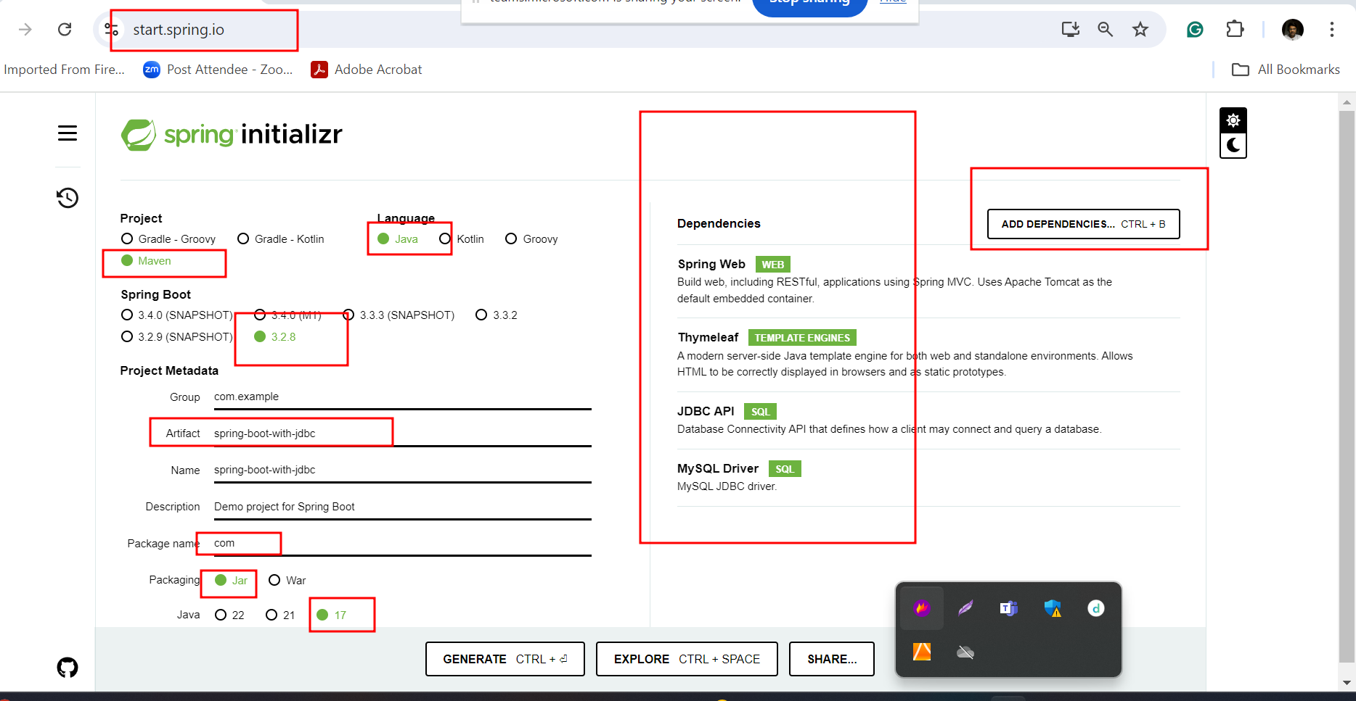

Thymeleaf notation

To access complex property

<tagname th:object=”${objectName}”/>

To access the property of that object

<tagName th:field = “*{fieldname}”/>

To access simple property

<tagName th:text “#{property}” />

To redirect from one page to another page using link or action

<form action=“@{path}”/>

</form>

Create table in database

create table login (emailid varchar(30) primary key, password varchar(30));